 VistA Application Analytics

RTEP: T4NG-0739 | VA-FY-24-00054128

August 15, 2024

 Veterans Health Administration

Technology Acquisition Center

23 Christopher Way

Eatontown, NJ 07724

Contracting Officer: Dana Newcomb | dana.newcomb@va.gov

Contract Specialist: Sarah Kuna | sarah.kuna@va.gov

Contract Specialist: Vanessa Woodward | vanessa.woodward@va.gov

|  |  |  |  |
| --- | --- | --- | --- |
|  |  |  |  |
| Submitted by:  **ThunderYard Liberty JV LLC**  1382 W. Melrose Dr.  Westlake, OH 44145 |  |  | DUNS: 117114077  CAGE: 8BX68  Unique Entity ID: LJM9BNU47VP8  **Laurence van der Oord**  Managing Venture Partner  larry@ThunderYard.com  281.222.3644 |

**Table of Contents**

1. Overall Understanding and Approach to Performing All VistA Application Analytics Services (RTEP B.1-B.3, PWS 5.2, 5.3) 1

2. Approach to Meeting the Requirements of the Performance Work Statement (PWS) – RTEP B.1 2

2.1. Approach to VistA Client Traffic Capture and Analysis (Base Period - PWS 5.2 and Option Period – PWS 5.3) 4

3. GANTT Chart with Expected Start and Completion Dates – RTEP B.2 12

4. Estimated Level of Effort – RTEP B.3 15

Table 1: TLJV’s Core Solution Features for VistA Client Traffic Capture and Analysis 2

Figure 1: Team TLJV Organizational Structure 5

Figure 2: Our Proposed VistA Application Analytics Architecture 8

Figure 3: Metrics Feeding Client Use Improvement Reports 10

Figure 4: VistA Application Analytics Base Year GANTT Chart (IAW PWS 5.1, 5.2) 13

Figure 5: VistA Application Analytics Option Year GANTT Chart (IAW PWS 5.1, 5.3) 14

Figure 6: TLJV Estimated Level of Effort (PWS 5.1 – 5.3) 15

# Overall Understanding and Approach to Performing All VistA Application Analytics Services (RTEP B.1-B.3, PWS 5.2, 5.3)

ThunderYard Liberty JV LLC (TLJV) respectfully submits our Task Execution Plan (TEP) for **VistA Application Analytics.** Team TLJV includes Managing Venture Partner ThunderYard Solutions LLC (MVP ThunderYard), a Service-Disabled Veteran Owned Small Business (SDVOSB), and Joint Venture Partner (JVP) Booz Allen Hamilton. The Veteran Health Administration (VHA), Clinical Informatics and Data Management Office’s (CIDMO), Veteran Health Data Program’s vision for VistA Application Analytics (VAA) is to drive improved standards of practice via a detailed analysis of representative traffic identifying point-of-care applications, user behaviors, patterns of clinical use, and areas of concern. This will ultimately provide a capability to provide real-world clinical workflow analytics and provide a data-driven approach for improvement and standardization of clinical workflows. While the VA previously ran 130 separate VistA instances across its network, each with different configurations, the recent migration of VistA into the VA Enterprise Cloud (VAEC) has provided an opportunity for increased manageability and streamlined maintenance. VistA’s transition to the VAEC has allowed for improvements in four key areas: 1) streamlined systems integration with new devices, diagnostics, and services; 2) enhanced analytics and artificial intelligence (AI) capabilities; 3) greater adherence to standards-based interoperability; and 4) increased usage of cloud streaming services such as telehealth and virtual care.

VA faces several challenges of strategic importance that require the accelerated and validated capture and analysis of Remote Procedure Call (RPC) traffic. Providing cutting edge care for Veterans requires continuous innovation and a resilient focus on testing and validating new solutions enabled by cloud technologies. VA faces challenges to continually improve access to care, customer service, quality of care and outcomes, and clinician experience. All while effectively managing costs in an era of tightening budgets, increased competition from Community Care outflows, and amplified technical complexity from digital solutions with limited off-the-shelf interoperability with VA legacy infrastructure. For VA, the outcome is that it is difficult to identify where to invest and what clinical care activities will effectively drive better care.

VA is positioned to address these challenges as it has made significant investment to migrate VistA to the Cloud and establish a Zero-Trust Security framework that allows for RPCs to be streamed securely and monitored anywhere. However, while significant enhancements have been made to the underlying infrastructure, continued work is needed to monitor the workflows of VistA Applications and provide a data-driven approach for optimizing clinical staff workflows and efficiency via analytics to effectively enable better clinical care delivery by 380,000+ clinical staff across 1,500+ care facilities.

Our highly feasible approach outlined in Section 2 below will provide CIDMO the following benefits from the VAA program: 1) identification of real-world usage of VistA Applications and timings for all user interactions, providing opportunities for improved User Experience; 2) identification of highly utilized features, functions, or applications where additional Strategic Investments could be made; 3) identification of oft-used features, functions, or applications that might be consolidated to reduce maintenance costs; 4) identification of variations of use of the applications and workflows across different clinical settings that would benefit from Enterprise Standardization; and 5) identification of application inefficiencies, such as redundant workflows, that should be simplified.

Our place of performance for this work will be primarily situated in and around TLJV corporate offices in the Washington, DC metro area and Westlake, Ohio. In alignment with the Performance Work Statement (PWS), we will also deliver experienced team members from across the country to enable the highest quality staff to support VistA Application Analytics objectives.

# Approach to Meeting the Requirements of the Performance Work Statement (PWS) – RTEP B.1

The VA Healthcare system manages a significant amount of traffic daily through its VistA system. VistA manages over 200 million transactions and 50 million clinical reminders every day to provide the highest quality of Veteran integrated care, nationwide. VistA is critical to VA healthcare delivery and requires a non-invasive process to effectively capture and analyze traffic exchange between VistA clients and a subset of VAEC-based VistA systems. We understand that today the VA utilizes AWS mirroring technology to mirror RPC calls into Amazon Web Services (AWS) Kinesis and flows this data into AWS CloudWatch. This provides an ability to effectively monitor over 50 million RPC calls per day.

TLJV proposes an approach that leverages our collective experience supporting the Veterans Health Administration (VHA), Office of Information and Technology (OIT) Health Services Portfolio, and VA’s Electronic Health Record Modernization Integration Office (EHRM-IO), with VA process expertise and technical implementation of solutions across VA Enterprise Cloud (VAEC) and Veterans Health Information Systems and Technology Architecture (VistA). Our solution approach brings a combined 75+ years of subject matter expertise partnering with VA to develop and maintain VistA, migrate legacy and modern applications into the VAEC, assess clinical workflows, and establish health data best practices.

Table 1 includes our core solution features that we will use on this Task Order. We will leverage our overarching solution features in support of all PWS areas, to include PWS 5.1, 5.2, and 5.3.

Table 1: TLJV’s Core Solution Features for VistA Client Traffic Capture and Analysis

|  |  |
| --- | --- |
| **Solution Feature** | **Summary of Approach** |
| **Deep VistA, MUMPS, and RPC Experience** | TLJV brings a dedicated team to support the VistA Application Analytics task including Architects, Data Scientists, VistA Data Experts, Cloud Engineers, VistA, MUMPS, and RPC engineers, Delphi/CPRS SMEs, Tech Writers, and Project Management. The VA RPC ecosystem is large, complex, and at times cryptic. It is comprised of over 5,500 legacy MUMPS code routines with a lack of clear documentation. Our team brings experienced VistA and MUMPS experts with an extensive background previously developing the original VistA as part of the VA. JVP Booz Allen provides Tier 3 Sustainment of 43+ VistA modules across multiple data domains within the Health Portfolio (i.e. Clinical Services, Scheduling, VHA Finance, Healthcare Environment and Logistics Management, Patient Care Services, Health Informatics, and VHA Front Office). Our operational support for these modules provides insight into how consumers use VistA modules across the VA. Our collective team brings over 50 MUMPS developers working across the Health Portfolio with over 950 collective years of experience working on VistA. Almost half of our MUMPS developers have 25+ years of experience. Our familiarity with VistA, MUMPS, and RPCs allows our team to hit the ground running in delivery without additional ramp up time. ***This expertise allows our team to efficiently analyze key metrics such as: determining which RPCs are read vs. write, matching task sets with the use of one or more specific client screens, and the distinction of clinical vs. non-clinical RPCs.*** |
| **Accelerated Stakeholder Engagement with VistA Sites** | Through our support of OIT Software Product Management’s (SPM) Health Services Portfolio, our team has direct and relevant experience with product sustainment for VistA and the VistA Office product line under the Legacy and Electronic Health Record Modernization sub-portfolio. This support provides our team unparalleled experience and reach to all VistA sites*.* ***Our existing relationships provide a significant strength to VA by streamlining and expediting coordination with the VistA sites identified for traffic capture and analysis.*** Ultimately, this will reduce any additional management overhead and accelerate performance on other critical tasks. |
| **Staff Ramp Up** | For the VistA Application Analytics task order, TLJV intends to bring available staff with existing VA access and Elevated Privileges to begin work immediately without the typical 1-2 month process of ramping up for new staff. The majority of our team possesses significant and recent experience with the underlying VistA, VAEC, and analytics technologies. The rest of our staff will be trained by our experts on all relevant project assignments. ***This approach provides a significant strength and benefits VA with the most experienced staff for meeting the objectives of the VistA Application Analytics program.*** |
| **VAEC and Real Time System Monitoring** | Team TLJV brings proven experience working within the confines and constraints of the VA OIT Enterprise Cloud Solutions Office (ECSO) VAEC. For the Joint Legacy Viewer (JLV) program, our team successfully migrated the application to the cloud and delivered all of the lower test environments, pre-production, and production environments required. Additionally, we set up AWS CloudWatch for real-time monitoring of VAEC AWS components. This capability also provided logging and automated alerts once components reach configured thresholds. For the VA Electronic Solution for Health Care and Occupational Recordkeeping of Employees (eSHORE) program, our team is deploying a SaaS product from Enterprise Health into the VAEC. On eSHORE we setup CloudWatch to monitor the application and respond to system-wide performance, optimizing resource utilization and obtain a unified view of operational Health. We utilized the VAEC role-based access control to authorize and restrict system access to users based on their assigned role. The Centralized Logging Solution (CLS) is setup by default to ingest information from CloudWatch and CloudWatch Log groups were created and added to the CLS. ***These engagements have provided our team directly relevant experience with VAEC operational tools, processes, services, and procedures that will accelerate our time to value on this task order.*** |
| **VistA Logging Experience** | TLJV has the unique ability to leverage knowledge of a fully operational similar application and will apply lessons learned on initiating new monitoring of logs and pulling information from VistA that we have cultivated over the last six years supporting the Data Migration and Syndication (DM&S) task in support of the Electronic Health Record Modernization Integration Office (EHRM-IO). During that time, we helped develop a system that monitored all the journals from all VistA sites (logging every change made on VistA) and extracted the data related to that change from the VistA shadow system to update into the VX130 database. Our team provides constant monitoring of the shadow system status displays for potential anomalies. |
| **Deep Clinical Workflow Insights** | Our team brings directly relevant experience supporting both the migration of data to and from Oracle Cerner post VistA migration as well as support for the OIT Community Care Product Line and VHA Office of Integrated Veteran Care (IVC). We are intimately familiar with the technologies, processes, and use cases associated with each of these programs. Our experience with these programs provides us with unique insights we will leverage to develop a more deeply informed set of recommendations in the Option Year. |
| **Health Care Data Science and Analytics Experience** | Our team brings significant experience with VA clinical data. We currently support over 50% of the Corporate Data Warehouse data domains and developed the initial strategy for VA’s Summit Data Platform (SDP) Data Architecture and DataOps program. Additionally, JVP Booz Allen is the industry leader in Artificial Intelligence (AI) and Machine Learning (ML) for the Federal Government and developed the Advana platform for the Department of Defense (DoD), a leading data and analytics platform helping analysts, mission owners, and data scientists make informed decisions across the DoD. ***Our deep bench of data scientists and health care data experts will bring specific subject matter expertise to conduct the analysis and recommendations*** ***to drive the VAA program forward.*** |

## Approach to VistA Client Traffic Capture and Analysis (Base Period - PWS 5.2 and Option Period – PWS 5.3)

TLJV has developed an advanced project management approach for our efforts using 75+ years of combined VA experience between our JV partners. Due to our successful cost control, schedule management, risk management, and task management, our average Quality Assurance Surveillance Plan (QASP) score across all T4NG TOs is 4.8 out of 5.0. TLJV is a Capability Maturity Model Integration (CMMI) Services Level 3 certified organization and employs an integrated approach to program management, focused on transparency and trust, with customer service, cost, schedule, and quality forming the pillars of our decision-making processes. Our team is fully knowledgeable of the tasks, activities, tools, processes, reporting requirements, and staffing controls required to successfully deliver the VistA Application Analytics program.

Our team of experts will collaborate with VA’s program management team, business owners, stakeholders, and other decision makers to validate our understanding of VistA Application Analytics’ critical success factors. Our integrated team will control all aspects of project execution and performance with a seamless and holistic approach to all areas of program responsibilities and deliverables as outlined in the PWS. Our team structure, as outlined in Figure 1 below, is comprised of a variety of skillsets required to meet the critical requirements of the VAA program:

* Program Manager – ultimate oversight responsibility for VAA delivery team
* Project Manager – provides day-to-day management and stakeholder communications
* Technical Lead (Architect, Sr) – guides the overall technical vision and approach
* AWS Cloud Engineer (Software/System Architect) – delivers the S3 Data Lake
* Data Scientists (Developer, Sr and Developers) – develop models and queries for analytics
* Technical Writer – documents reports in GitHub Markdown, Word, and PowerPoint
* VistA Subject Matter Experts and Delphi/CRPS Subject Matter Experts (Functional Area Expert II) – identify and explains RPC traffic types, origins, efficiencies, supports report generation, perform analysis on traffic data, provides insight into clinician facing-applications
* Sr VistA SME (Functional Area Analyst, Sr) – provide senior level VistA and CPRS expertise

As we move into the Option Year, our team structure will ramp down to take advantage of the processes and infrastructure put in place in the base year and will continue to execute against those proven approaches.

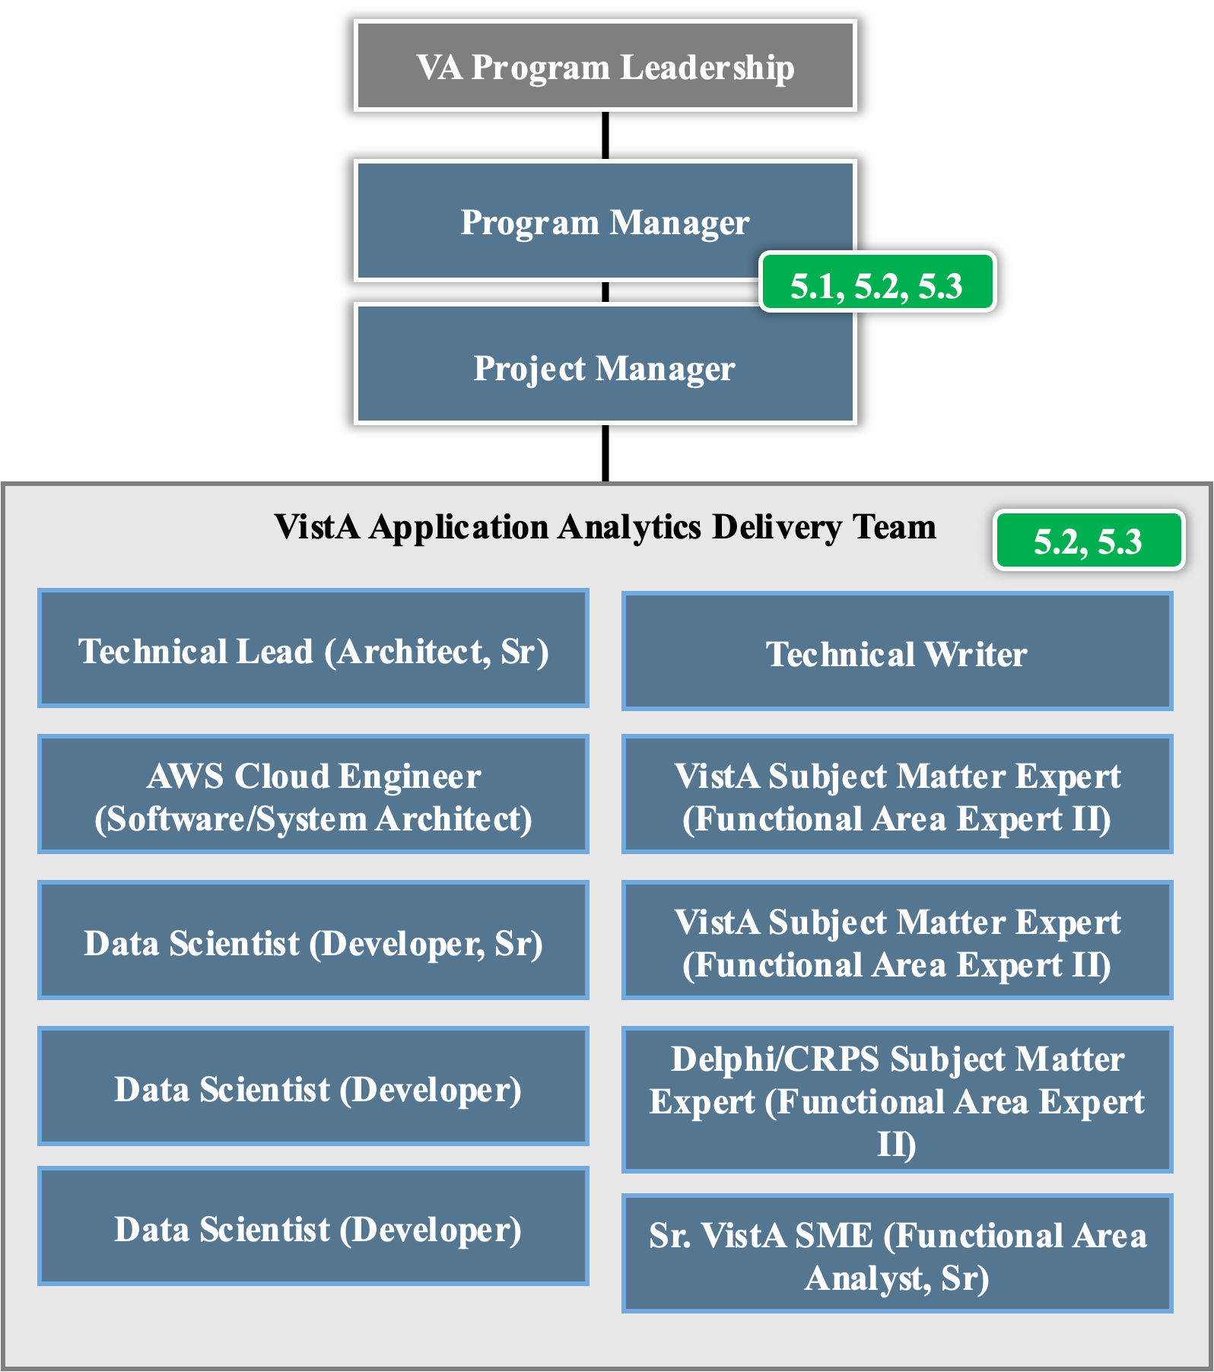

Figure 1: Team TLJV Organizational Structure

Following our planned project schedule outlined in Section 3 below, our Program Manager (PM), will establish our two-week Sprint cadence in coordination with the VA Program Manager and COR. Our team uses an agile-based project management approach emphasizing flexibility, collaboration, and iterative progress allowing for incremental value through continuous feedback and adjustments. Our PM will establish a Jira board to manage our backlog and prioritize tasks. We will use daily stand ups and Jira dashboarding to track team progress and ultimately generate customized reporting that will feed into our Monthly Progress Reports.

***Our proposed TLJV Program Manager previously spent five years as an IT Program Manager supporting the EHRM-IO program office.*** From December 2017 to January 2019, he managed a variety of VistA modernization work under the VistA Standardization and Security Enhancements (VSSE) effort including VistA Advanced Analytics and VistA Adaptive Maintenance. ***He worked closely with both the VHA PM (and current CIDMO Veteran Health Data Program Lead) and OIT PM to guide these precursors to the current VistA Application Analytics effort in their early stages. He will bring familiarity with these programs and the key clients/stakeholders to deliver VAA successfully.***

Additionally, as a significant strength, ***our VHA VistA Subject Matter Experts have decades of experience***, and these individuals have honed their skills in the development and maintenance of an extensive range of clinical and financial VistA applications. ***Their careers are marked by a deep expertise in VistA’s complex systems, including, but not limited to, the primary electronic health record system (CPRS), Patient Information Management, Appointment Scheduling, Pharmacy, Integrated Billing and Accounts Receivable systems.*** They have played a pivotal role in optimizing and evolving these applications to meet the evolving needs of the VHA, ensuring enhanced functionality, reliability, and integration across the healthcare system. Their extensive background combines technical proficiency with a thorough understanding of clinical workflows and financial processes, making them a key asset in driving continuous improvement and innovation within VistA.

#### Approach to Capture of VistA Client Traffic (PWS 5.2.1)

We understand that Cloud VistA (an open-source VistA community) was involved in the move of VistA to the cloud beginning in 2014. They identified that there are over 190 applications in VistA now at each instance (130 sites). 48 of those applications utilized Remote Procedure Call (RPC) as part of their process of transferring data. The Computerized Patient Record System (CPRS) application is identified as the largest of these with over 50 million transactions daily. In Cloud VistA’s research over two years, they monitored these transactions using CloudWatch on the Amazon Web Services (AWS) cloud system. Although the focus was on the security of those records, they established ways to monitor the transactions.

In accordance with PWS 5.2.1, our team will build upon the previous work of the Cloud VistA team. We will capture real-time data for a designated period of time (at least one month) using the existing “non-invasive” process of capturing all the RPC traffic (both cross-VistA and VistA-specific) with the specifics of what applications are involved with each transaction. We will also capture User info, End-User Identification and timestamps for each transaction (start / complete).

We understand that while a non-invasive mechanism already exists today for capturing RPC traffic for the VAEC-hosted VistAs, our Project Manager will negotiate access to the existing AWS Kinesis and CloudWatch data streams with the appropriate system owners within VA. We have in-depth experience on our eSHORE and Health DevSecOps (HDSO) programs with establishing MOUs with VistA information system managers. Our team also has over five years of experience interacting with the VAEC management team across a wide range of OIT projects. Our combined strengths in navigating access challenges will quickly allow us to gain access to the necessary components to support this task.

Our Project Manager will coordinate with the VA Program Manager for required access and permissions to VA systems, MOUs, and Authority to Operate (ATO) as required. Our team brings experience with these processes from past VA engagements and our proposed team comes with existing VA access and elevated privileges. For the identification of three VistA sites, our VistA SMEs (Functional Area Expert II) will conduct analysis to identify a broad set of sites to choose from, with at least one of them being a large integrated VA Medical Center. We will use objective and subjective criteria in determining which VistA sites to analyze. We will look at factors such as geographic location, VISN alignment, size, complexity (multiple VAMC’s), number of associated clinics, Veteran population demographics, medical specialties, and amount of customization among other factors. We will leverage our team experience with the VistA Office product line under the Legacy and Electronic Health Record Modernization sub-portfolio to engage appropriate individuals responsible for each of the identified VistAs at each site. Our existing relationships will allow us to expedite the approval process to capturing RPC traffic. Our team will work with identified VistA POCs and the VA Program Manager to identify what data is required for capture, where it is located, and then determine the most efficient approach to capture that data.

Leveraging existing VAEC technologies like AWS Kinesis, our AWS Cloud Engineer will support the establishment of a data lake using AWS Simple Storage Service (S3), housing both unstructured and structured data. This data lake will contain a range of pre-processed data to support current and future iterations of analysis to determine the types of tasks performed by the various disciplines of health care professionals, ancillary systems, and the amount of time spent performing these actions. AWS S3 interacts with nearly all AWS Cloud Native Analytic and machine learning services which enables future-state analytics and modeling iterations to occur without incurring duplicative efforts. We will monitor and log traffic for the three VistAs for at least a month and store all the captured data for analysis. Our strengths with additional VAEC services such as CloudWatch will also be used to monitor the stability of the RPC traffic data ingest. We will ensure that alerting exists should any of the various streams fail or significant spike occur that indicate anomalies occurring with upstream systems.

We will continue to iterate on our approach to ensure the most efficient mechanism for RPC traffic capture has been operationalized and that our approach is extensible. As the amount of data increases, VA will have the ability to pursue new insights and refine existing models. We will document our process in the VistA **Traffic Logging Standard Operating Procedure (PWS Deliverable 5.2.1.A)** in a GitHub repository using the GitHub flow methodology. As we deliver these standard operating procedures, we will use a GitHub Pull Request to provide configuration management and an approval workflow to VA that is seamless and intuitive. We will also create GitHub Actions (such as linting the Markdown code if utilizing the DoVA org under github.com) or Self-Hosted runners that perform automated quality checks on our deliverables as they are submitted in markdown (if using the VAEC GitHub instance) as a way to ensure high-quality and transparency.

All our product documentation will be stored on the VA GitHub site where we will establish a new VistA Application Analysis (VAA) project. This will allow consistent updating of documents and coding work done by all team members. Our familiarity of the GitHub application will help utilize the markdown features and keep everyone in sync as we progress. Our stakeholders will also have access granted to participate and monitor our team’s progress.

#### Approach to Analysis of VistA Client Traffic (PWS 5.2.2)

The second objective of this contract is to create and document a repeatable analytical process that can be executed against the unstructured and structured data in the VAEC data lake. This process will initially focus on analyzing the RPC data captured from three VistA Sites for a period of one month. This first analysis will provide a glimpse into which applications use the most volume and whether those are Clinical or Non-Clinical applications as well as whether they use Cross-VistA traffic. That initial review will help our team build the best framework for reporting trends, specifics, which applications are most prevalent and other metrics to include and complete the analysis on. TLJV will develop a VA Enterprise GitHub site to document how these reports are created as well as capture the rinse-and-repeat process for adding new reports. We will create a data quality program to ensure that all this data is captured and stored correctly as well as verified with other metrics.

VAEC facilitates many cloud native tools for performing advanced analytics, to include DataBricks, Athena Spark, TensorFlow and SageMaker. Our Data Scientists are prepared to provide an analysis of alternatives to VA stakeholders while the activity in PWS 5.2.1 is underway. We will provision the best-in-class machine learning or descriptive analytics engine based on the data being introduced and the determination of the VA stakeholders. As an example of our deep experience with these advanced analytics tools, for the Financial Service Center (FSC) Data Analytics Services (DAS), JVP Booz Allen conducted a full architecture and dimensional model redesign to transition the legacy data analytics program from on-premises to MS Azure, and from legacy to new technology such as low code/no code. We architected full scale cloud solutions for DAS, including staging databases, data warehouses, business intelligence (BI) front ends, and delivered architectural diagrams for cloud implementation. We developed 700+ visualizations using Power BI and Tableau; 600+ deliverables including architectures, schemas, models business rules, and designs; and data management and ingestion for 93 databases and 75,000 data elements. Our team incorporated Azure Data Factory, Azure Data Lake, Azure Databricks, R, Python and advanced analytics (e.g., deep neural networks) to translate physician-transcribed notes into International Classification of Diseases code. Our architectural shift from on-premises ETL to cloud using Azure Data Factory and Databricks and leading-edge technology solutions in Artificial Intelligence/Machine Learning (AI/ML) and data visualization enabled larger data projects and maximized efficiency and ingestion.

Figure 2 below outlines our proposed VAA architecture in support of this program.

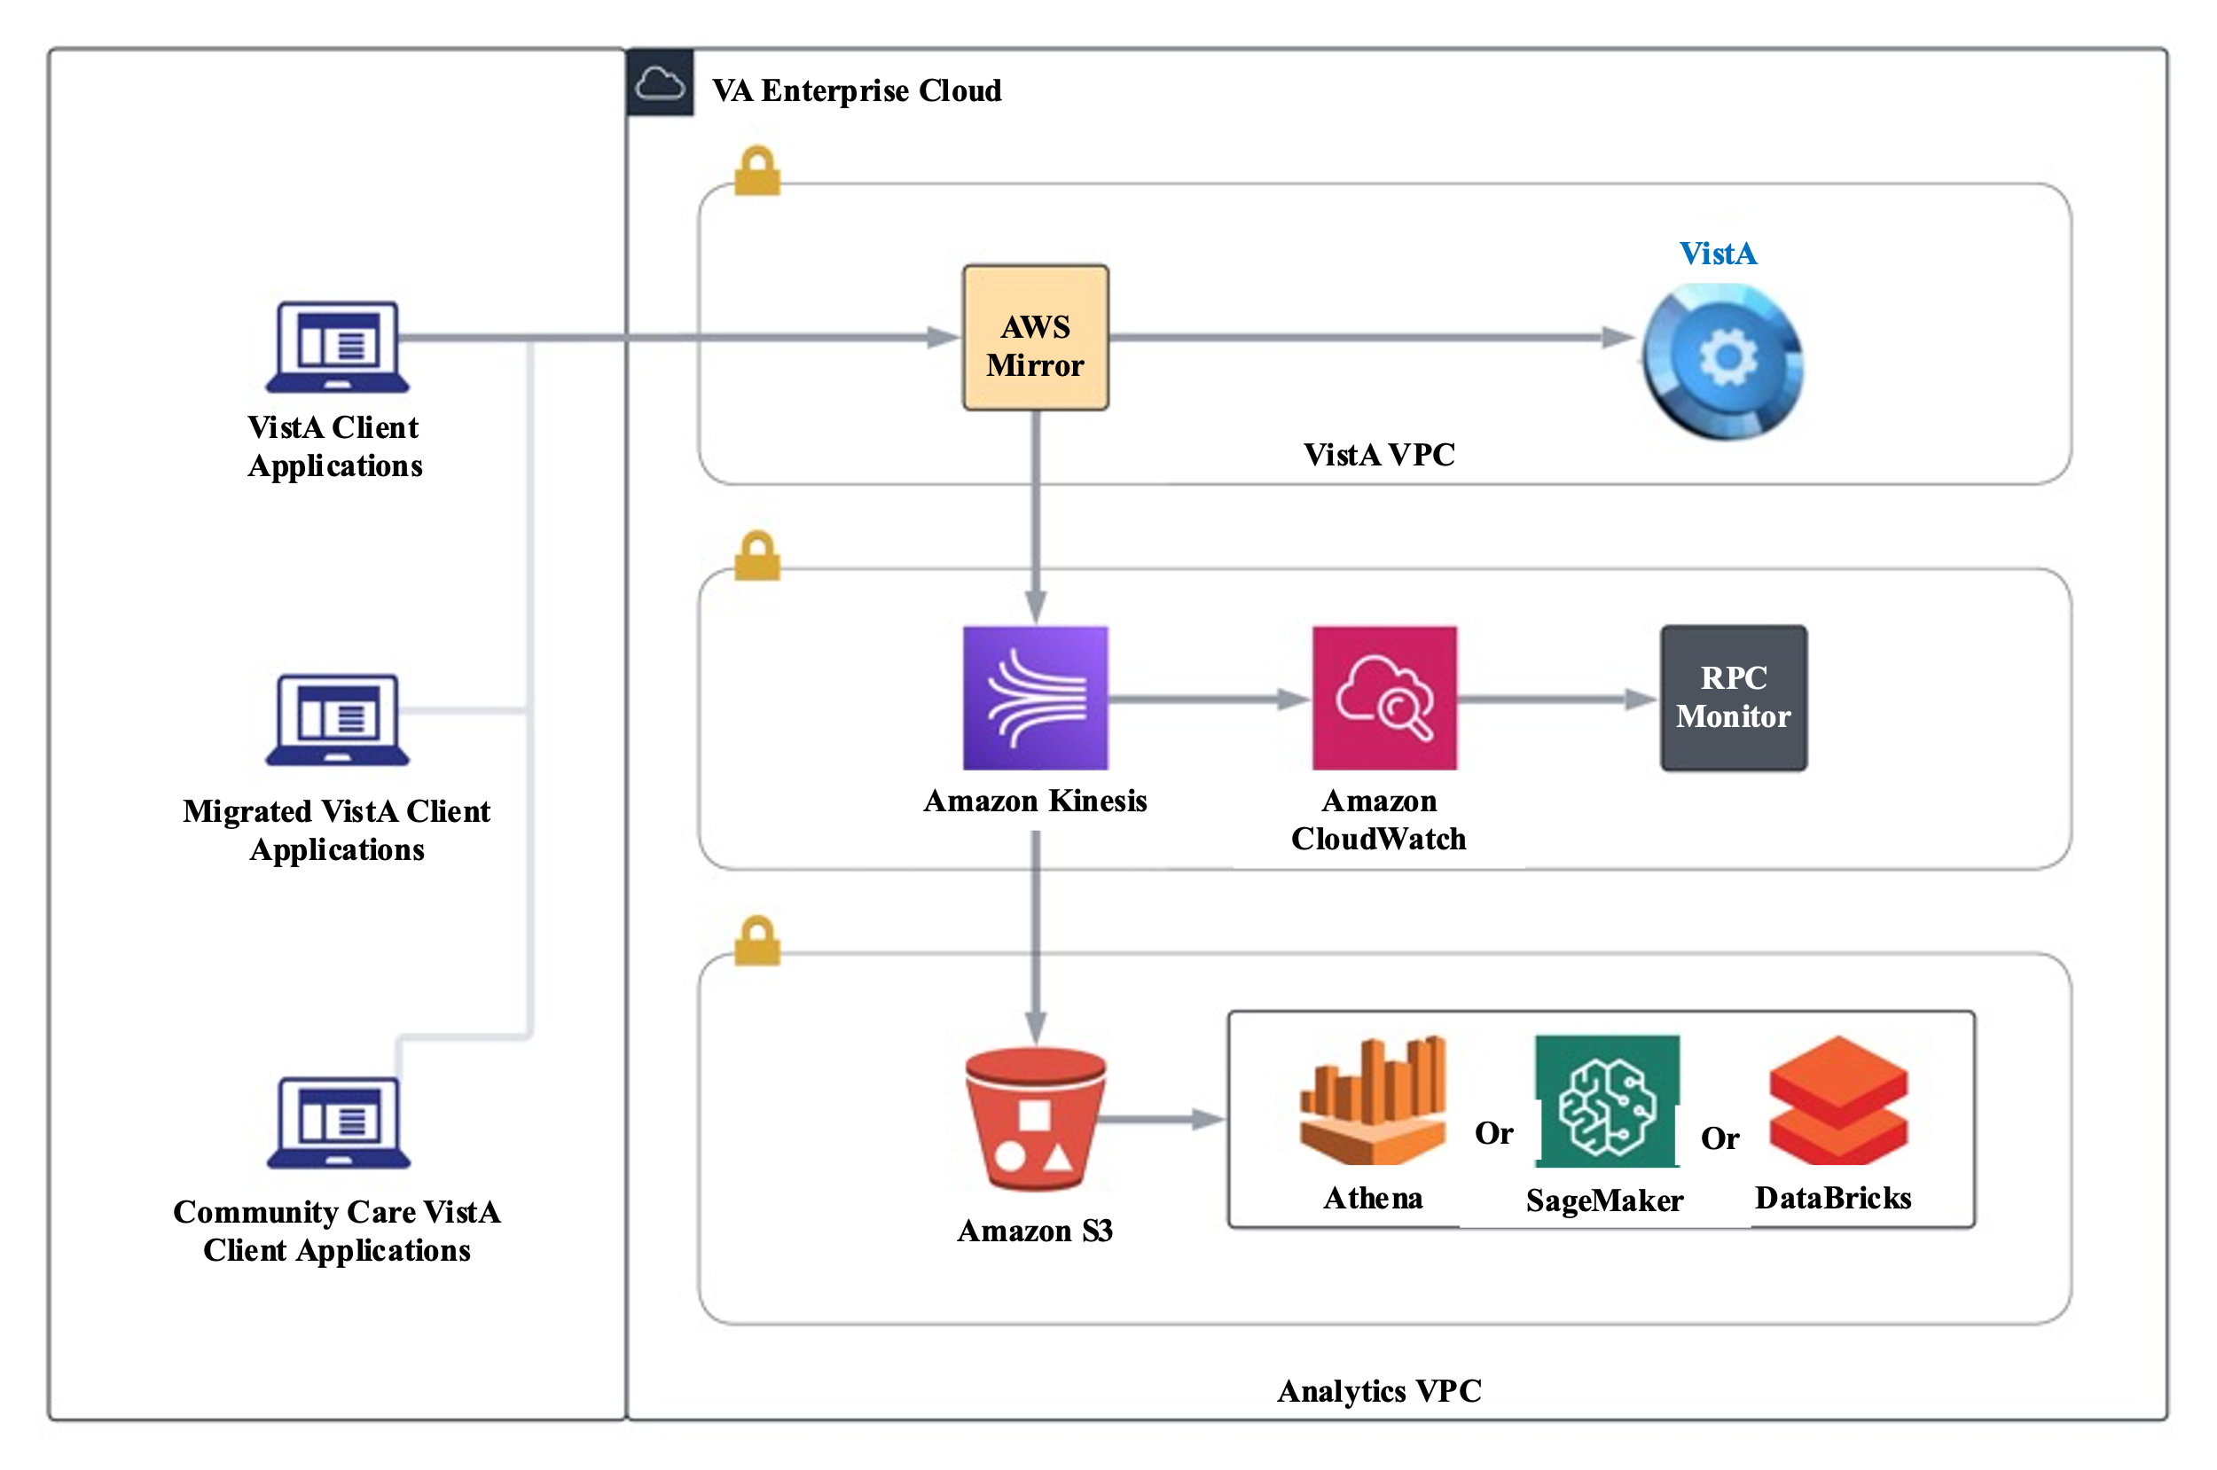

Figure 2: Our Proposed VistA Application Analytics Architecture

Our Technical Writer will create four separate reports, supported by our Data Scientists and VistA SMEs, that together will depict the complete client traffic profile using the data collected in PWS 5.2.1. Three of these reports **(Traffic Analysis Reports, Deliverable 5.2.2.A)** will utilize all available data captured to include: User volume, Client types, Connection (volumes, frequency, and duration), Types of user authentication, End Users, RPC usage (frequency, execution times and groupings) and RPCs specific to each VistA from cross-VistA RPCs. Additionally, our reports will capture the complete client traffic for each of the three VistA sites. A fourth report **(Cross VistA Traffic Analysis Report, Deliverable 5.2.2.B)** will capture all cross-VistA traffic report that details cross-VistA from VistA specific traffic patterns that emerge from the data being collected. These reports will be built iteratively where the VA stakeholders are kept informed of findings and observations regularly during our sprint cycles.

These reports will be submitted to the GitHub repository using the industry standard GitHub flow branching standard. As we deliver these reports, we will use a GitHub Pull Request to provide configuration management and an approval workflow to VA that is seamless and intuitive. We will also create GitHub Actions (such as linting the Markdown code if utilizing the DoVA org under github.com) or Self-Hosted runners that perform automated quality checks on our deliverables as they are submitted in markdown (if using the VAEC GitHub instance) to ensure high-quality and transparency. As an example of our deep familiarity with VA’s Enterprise GitHub, JVP Booz Allen’s Lighthouse team uses GitHub to successfully produce monthly, quarterly, and ad hoc Markdown reports over the last four and a half years supporting the program.

#### Approach to Analysis of Use of Key VistA Clients (PWS 5.2.3)

The third objective of this contract is to create a process to analyze the traffic data for three specific VistA Clients (Applications). TLJV will utilize a GitHub repository to capture these reports as is done in the previous sections. The primary purpose for these reports is to see which applications (Clients) are the primary consumers of VistA data.

Our Technical Writer, in concert with our Data Scientists, VistA SMEs, and Delphi/CPRS SME, will create one standardized Client Use Analysis Template **(Three VistA Client Use Analysis Reports, Deliverable 5.2.3.A)** that can be reused for subsequent reports to capture user volumes and types, Connection volume and duration, types of user authentication, Patient volumes, RPC volume used by a client, Distinction of clinical from non-clinical RPCs, Read / Write RPC Volumes, Runtimes for RPC’s to show slow running or high overhead, Clinical care task sets, Match task sets and Task sets employed by different user types. One of these reports will focus specifically on the predominantly used CPRS client and the other two will be approved by VA stakeholders after we have provided them with early insights into the utilization of other, non-CPRS clients. The fourth report will contain Key Performance Indicators and other validation metrics that indicate the accuracy of the analysis being used **(Client Analysis Validation and Verification Report, Deliverable 5.2.3.B)**.

We will work with clinically active VA informaticists to identify hotspots in application inefficiency and latency. The report will utilize all available data captured to both inform VA leaders which VistA clients (applications) are underused and or underperforming, making them candidates to be sunset and also which VistA clients are highly used but are characterized based on KPIs as being the greatest candidates for investment and enhancement. These markdown reports will be pushed to a GitHub repository and will use a GitHub Pull Request to provide configuration management and an approval workflow to VA that is seamless and intuitive.

#### Approach to VistA Client Use Improvement Report (PWS 5.2.4)

The fourth objective of this contract is to assess the insights gained from the previous analysis of the three VistA Clients (Applications) and determine how they would deliver better outcomes if they were prioritized for upgrades and enhancements. Our VistA SMEs and Delphi/CRPS SME will leverage the three VistA Client Use Analysis Reports produced in PWS 5.2.3, using the standard template and KPIs to follow an apples-to-apples comparison and facilitate developing clear, data-backed recommendations for each of three most-utilized VistA clients.

The deliverable reports **(Client Use Improvement Reports, Deliverable 5.2.4.A)** will include other domain specific considerations, such as, where should the SSL payloads be decrypted, how are the RPC’s grouped currently, are calls serialized, how are connections established as well as other ways to “judge” the performance of the system. The resulting analysis will provide recommendations for future considerations for improvement of the patient care process. The report will also incorporate other industry standard factors, to include Response Time, Throughput, Error Rate, Network Latency, Concurrency, and Dependency Health (see Figure 3 below).

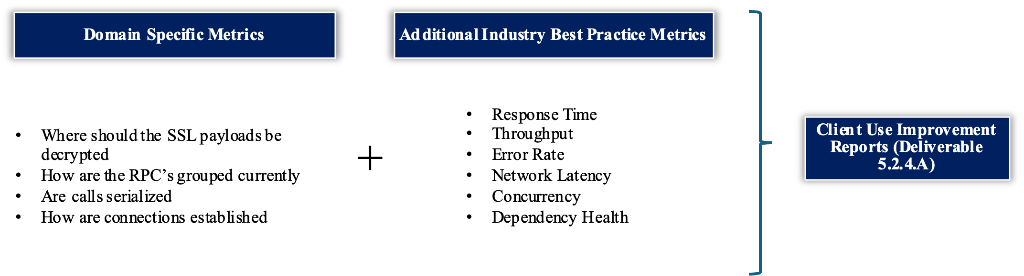

Figure 3: Metrics Feeding Client Use Improvement Reports

As stated in our introduction, our ultimate intent in developing these Client Use Improvement Reports is to drive improved clinical care. We will align our recommendations around the overall objectives of the VAA program:

1. Improving User Experience based on analysis of real-world timings and real-world usage of VistA applications
2. Identifying highly utilized features, functions, or applications where additional Strategic Investments could be made
3. Identifying oft-used features, functions, or applications that might be consolidated to reduce maintenance costs
4. Providing Enterprise Standardization opportunities based on the variation of applications and workflows across different clinical settings
5. Identifying application inefficiencies, such as redundant workflows, that should be simplified

We will include VA stakeholders in the development of the three Client Use Improvement Reports, incorporating incremental checkpoints, to ensure that the developing products are in line with the final expectation from the VA program leadership. These will be delivered in the form of detailed Word document reports and a corresponding PowerPoint presentation to facilitate the dissemination of the analysis findings and recommendations.

#### Approach to Migrated VistA Client Traffic Analysis (PWS 5.3.1)

Moving into the Option Year, our team enact our VistA Traffic Logging Standard Operating Procedure and will capture and non-invasively analyze the traffic data for a Migrated VistA site for one month and determine what effect the migration to the Millennium system has on that site’s network traffic. Following sites migration to Cerner, the Migrated VistA remains in production with a limited set of functionalities. TLJV will utilize the methodology documented in section 2.1.1 to ingest this data for a large Migrated site, leveraging a data lake using VAEC Simple Storage Service (S3), housing both unstructured and structured data. We will leverage all lessons learned from the base year around collecting, storing and analyzing this data.

As established during the Base Year, we will have all the metrics set up for collection and analysis of the data captured. For Migrated site data, we will work with our VA Program Manager to identify one of the largest Migrated sites and begin capturing the data elements for that site. Having established a baseline of metrics for three other sites, we will use them to compare against the migrated site data and follow the processes and procedures outlined in our SOPs. Based on the data captured for migrated sites, we will be able to monitor the volume of users for each client’s transaction decrease or increase. If there are additional Cross-VistA clients, including the Millennium system, we will capture that information as well.

Our TLJV team manages the actual Migration to the Millenium system through our work with the Data Migration and Syndication (DMS) program in support of EHRM-IO. ***We helped extract the original VistA data for the sites, helped write all the cutover queries for the migration itself, maintained all the real-time data being pushed to Oracle after Go-Live and supported the overall effort over the past five years. Those lessons learned and experience is a significant strength that will help our team review the data traffic and analysis and know where to look for changes to that traffic.*** Additionally, our team has existing relationships with the individual VistA sites that have already migrated in Spokane, Walla Walla, Columbus, Roseburg, White City, and North Chicago. We will leverage those relationships to ensure a seamless coordination when completing our analysis and helping to determine the best Migrated VistA site for analysis.

The full analysis of the data captured will include other considerations like Identify which VistA and Cross-VistA clients are still in use and how they are used, Identify the type and volume of users still operating in this VistA, Identify the subset of RPCs still being used and compare this new data to the range of RPCs used in full VistAs. This data will be used to create a detailed **Migrated VistA Traffic Analysis Report (Deliverable 5.3.1.A)** written in Markdown and pushed to the GitHub repository. As we deliver these reports, we will use a GitHub Pull Request to provide configuration management and an approval workflow to VA that is seamless and intuitive.

#### Approach to VistA Community Care Client Traffic Analysis (PWS 5.3.2)

As we capture and analyze traffic data for the Migrated VistA site, we will also capture and analyze client traffic Community Care data for a production VistA site over the course of one month. TLJV will utilize the capturing of the site data perfected in section 2.1.1 for Community Care and apply this same machine learning or descriptive analytics solution based on the previous determination of the VA stakeholders. We will leverage all lessons learned from the base year around collecting, storing, and analyzing this data.

To ensure a more representative capturing of data for Community Care Client traffic, we will choose a site with a wider range of Community Care Locations. Some VistA sites only have a few and some sites have over 100 Clinics. We will use the same approach for coordinating with VistA sites that we outlined in section 2.1.1. We will also build a subset using the Location for all these Clinics to separate and analyze that data separately. To produce a high-quality deliverable, we will perform analysis with the intent to discover characteristics of types, volumes, and sources of parseable text, images and screenshots, utilization and display of this data by both pre-existing and specialized VistA clients, and in-depth recommendations on how to better integrate this information within existing clinical and non-clinical data.

TLJV will analyze the captured traffic related to Community Care and make recommendations on how to better integrate this external information with VA clinical and other data. Our team brings extensive experience supporting both business and technical aspects of the VA Community Care Program, all the way back to when it was called VA Choice. Our team will leverage subject matter experts from that work to help inform our recommendations. We will document the traffic capture, analysis, and recommendations in a **VistA Community Care Traffic Analysis Report (Deliverable 5.3.2.A).** As with all previous sections, these reports will be delivered using an iterative process to ensure that VA Stakeholders can engage as the work is taking place. We will develop these reports in markdown and push them as code into the GitHub repository using the industry standard GitHub flow branching standard. As we deliver these reports, we will use a GitHub Pull Request to facilitate and streamline approval workflow for VA that is seamless and intuitive. We will also create GitHub Actions (such as linting the Markdown code if utilizing the DoVA org under github.com) or Self-Hosted runners that perform automated quality checks on our deliverables as they are submitted in markdown (if using the VAEC GitHub instance) as a way to ensure high-quality and transparency.

# GANTT Chart with Expected Start and Completion Dates – RTEP B.2

Outlined below in Figures 4 and 5 is our initial proposed project schedule for the VistA Application Analytics task order. Figure 4 depicts the Base Year set of activities, start and completion dates, and milestones (PWS 5.1 and 5.2). Figure 5 depicts the same set of information but for the Option Year tasks (PWS 5.1 and 5.3). Upon award, our PM will work with the VA Program Manager to refine these timelines and finalize an initial roadmap.

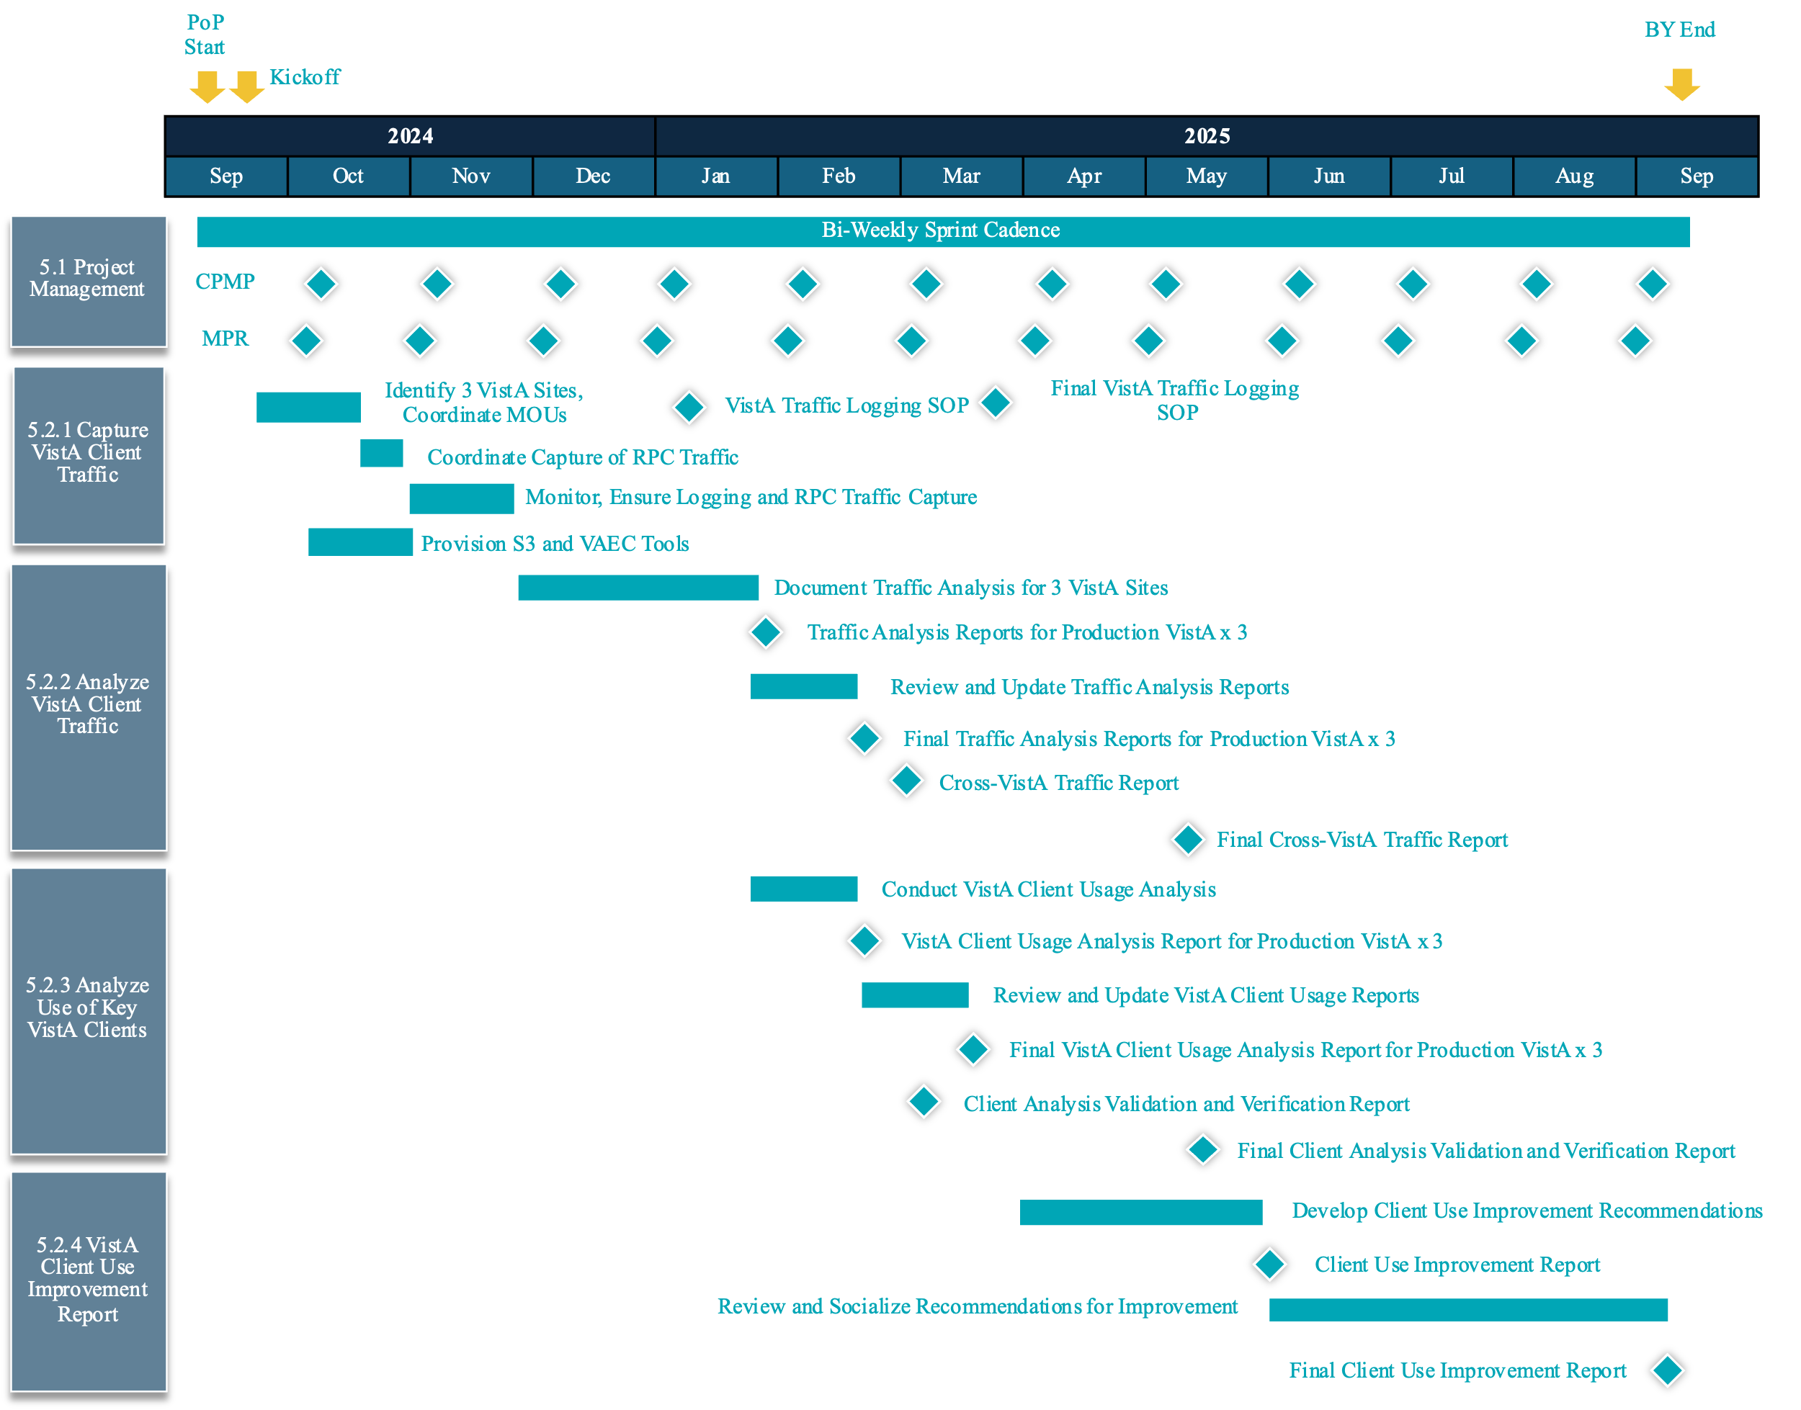

Figure 4: VistA Application Analytics Base Year GANTT Chart (IAW PWS 5.1, 5.2)

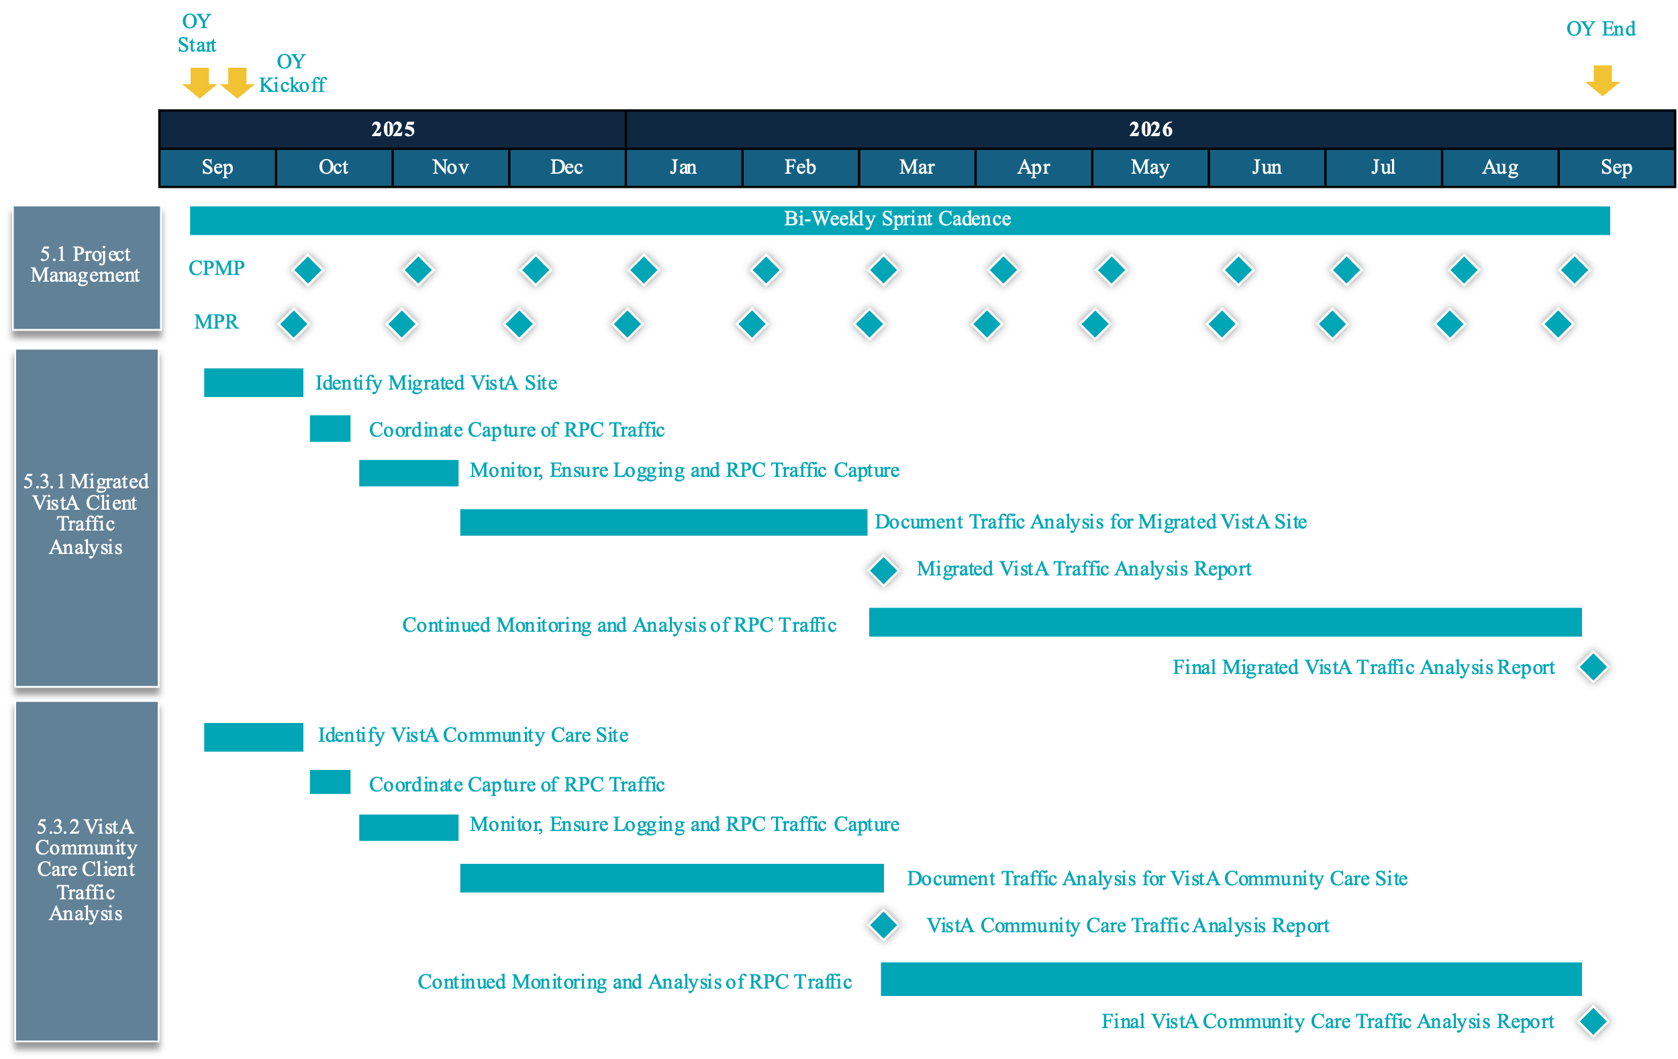

Figure 5: VistA Application Analytics Option Year GANTT Chart (IAW PWS 5.1, 5.3)

# Estimated Level of Effort – RTEP B.3

Figure 6 below outlines the estimated level of effort (LOE) for Team TLJV’s approach for PWS sections 5.1, 5.2, and 5.3 and all subparagraphs (5.x.x). The LOE includes labor categories (LCATs) and associated hours for TLJV for the base and option periods throughout the period of performance.

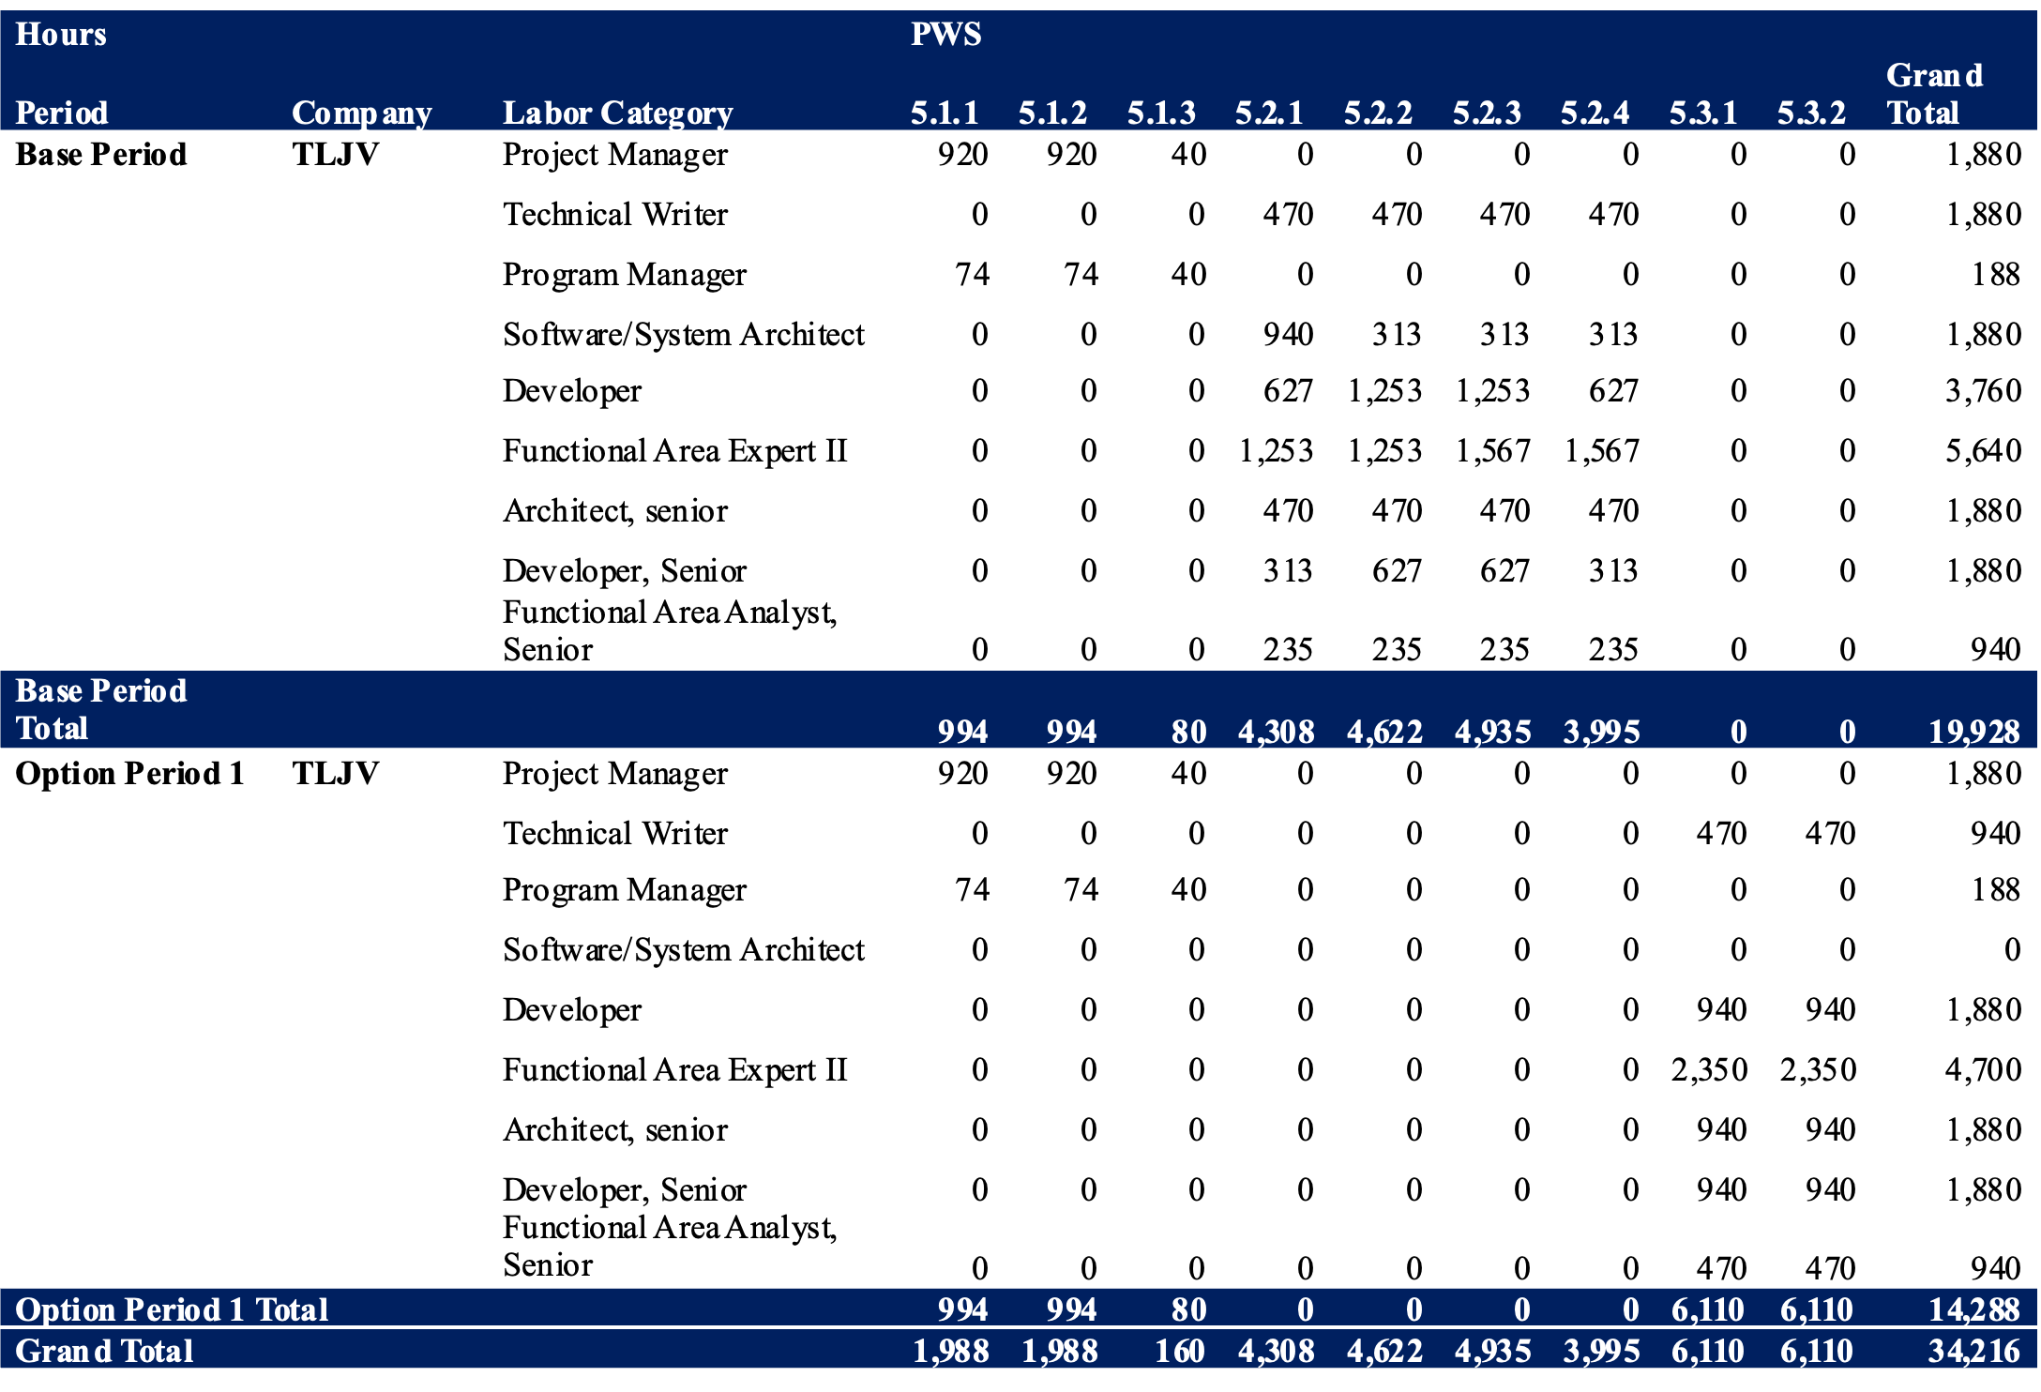

Figure 6: TLJV Estimated Level of Effort (PWS 5.1 – 5.3)